CHAITANYA MEDICAL FOUNDATION’S COLLEGE OF PHYSIOTHERAPY

CHINCHWAD, PUNE -19

A

PROJECT REPORT

ON

**“EFFECT OF CYCLING VERSUS RETRO-WALKING ON PAIN, PHYSICAL FUNCTION IN PATIENTS OF OSTEOARTHRITIS OF KNEE**

**[GRADE 1 & 2]”**

**-A COMPARATIVE STUDY.**

SUBMITTED BY

MEGHA YOGESH AGARWAL

UNDER THE GUIDANCE OF

DR. ABHISHEK PANCHAL (PT)

A PROJECT SUBMITTED TOWARDS PARTIAL FULFILLEMENT OF THE INTERNSHIP PROGRAM FOR THE DEGREE OF BACHELOR’S OF PHYSIOTHERAPY AS PRESCRIBED BY MAHARASHTRA UNIVERSITY OF HEALTH SCIENCE, NASHIK.

**EFFECT OF CYCLING VERSUS RETRO-WALKING ON PAIN, PHYSICAL FUNCTION IN PATIENTS OF OSTEOARTHRITIS OF KNEE [GRADE 1 & 2]**

**A COMPARATIVE STUDY.**

**UNDER THE GUIDANCE OF: PROJECT BY :**

**DR. ABHISHEK PANCHAL MS. MEGHA AGARWAL**

**CERTIFICATE**

**Department of Physiotherapy**

This is to certify that **MS. MEGHA YOGESH AGARWAL** has satisfactorily carried out the synopsis titled as –

**“EFFECT OF CYCLING VERSUS RETRO-WALKING ON PAIN, PHYSICAL FUNCTION IN PATIENTS OF OSTEOARTHRITIS OF KNEE [GRADE 1 & 2]”**

**- A COMPARATIVE STUDY.**

As a part of the curriculum specified by the Maharashtra University of Health Sciences , Nashik for internship program from September 2023 - March 2024.

GUIDED BY PRINCIPAL

DR. ABHISHEK PANCHAL DR. SHILPA PARAB

M.P. Th (Neuro Physiotherapy) M.Ph.T (Cardio Respiratory)

**ACKNOWLEDGEMENT**

Firstly, I would like to thank God whose grace helped me to conduct and complete the project. I would like to extend my sincere gratitude to my Principal DR. SHILPA PARAB for giving me the opportunity to present this project. I thank my guide DR. ABHISHEK PANCHAL for his precious time, guidance and timely suggestions throughout the study and for granting me the permission to conduct my study. I would like to thank my parents, colleagues and friends for helping me all through this project and giving me the much required moral as well as financial support. I would like to thank all my subjects who participated in the study and co-operated with me.

I wish to express my sincere gratitude to all those who helped me directly or indirectly throughout this project.

**INDEX**

|  |  |  |
| --- | --- | --- |
| **Sr.No.** | **TOPIC** | **Page no.** |
| **1.** | **INTRODUCTION** | **6** |
| **2.** | **NEED OF STUDY** | **9** |
| **3.** | **AIM & OBJECTIVE** | **10** |
| **4.** | **HYPOTHESIS** | **11** |
| **5.** | **REVIEW OF LITERATURE** | **12** |
| **6.** | **MATERIAL & METHODOLOGY (ELIGIBLITY CRITERIA)** | **15** |
| **7.** | **PROCEDURE & OUTCOME MEASURES** | **17** |
| **8.** | **STATISTICAL ANALYSIS** | **21** |
| **9.** | **RESULTS** | **22** |
| **10.** | **DISCUSSION** | **30** |
| **11.** | **CONCLUSION** | **33** |
| **12.** | **LIMITATIONS, FUTURE SCOPE, CLINICAL IMPLICATION** | **34** |
| **13.** | **EVALUATION SHEET** | **35** |
| **14.** | **ANNEXURE – I** | **37** |
| **15.** | **ANNEXURE – II** | **39** |
| **16.** | **REFERENCES** | **40** |
| **17.** | **MASTERCHART** | **43** |

**INTRODUCTION**

The knee joint is one of the largest and most complex joints in the body. It is a bi-condylar type of synovial joint which is composed of two distinct articulations located within a single joint capsule: the tibiofemoral joint and the patellofemoral joint. It allows for flexion and extension and a small degree of medial and lateral rotation.

Osteoarthritis (OA) is influenced by various risk factors that contribute to its development and progression. Old age is a significant risk factor, as the incidence of OA increases with advancing age. Additionally, women have higher prevalence of OA compare to men. Obesity is another prominent factor, as it is associated with a higher incidence of OA, particularly in weight-bearing joints .[1] Osteoporosis, a condition characterized by low bone density, is also linked to a higher risk of developing OA and slower disease progression.[2]

Occupation plays a role in OA risk, especially if it involves repetitive activities that put strain on joints. Certain sport activities, particularly those involving high impact and joint loading, can contribute to the development of OA. Muscle weakness resulting from inactivity, poor training or prior injury can also increase the risk of OA. Proprioceptive deficit, which refers to a diminished sense of joint position and movement, can be caused by age, comorbidities, illnesses or anterior cruciate ligament (ACL) ligament injury are associated with OA knee. Finally, genetic factor plays role in OA although they are not preventable or modifiable.[3]

The pathology of OA primarily affects the articular cartilage, which undergoes degenerative changes.[4,5] The initial changes observed include, increase in water content and depletion of proteoglycans from the cartilage matrix. Over time, weight-bearing on such compromised cartilage lead to fibrillation, resulting in cartilage abrasion and exposure of underlying bone. The subchondral bone in the affected area becomes hard and glossy through rubbing. Additionally, the bone at the joint margin hypertrophies, forming osteophytes or projecting spurs. This process can lead to the formation of subchondral cysts and sclerosis. Loose flakes of cartilage can incite synovial inflammation and thickening of the joint capsule, ultimately causing joint deformity and stiffness.[6]

Diagnosis of OA in the knee involves evaluating the severity of the articular cartilage surface damage, which can be classified into several grades. Radiographic evaluation, including weight-bearing (AP) view of the knee, lateral & skyline view if necessary for assessing the extent of joint involvement.[7,8]

The grades of Kellgren-Lawrence grading scale, ranging from normal to severe grade (1-4) based on the presence of the osteophytes, joint space narrowing & subchondral sclerosis.

GRADE 1 – NARROWING OF JOINT SPACE WITH POSSIBLE OSTEOPHYTE FORMATION

GRADE 2 – POSSIBLE NARROWING OF JOINT SPACE WITH DEFINITE OSTEOPHYTE FORMATION.

GRADE 3 – DEFINITE NARROWING OF JOINT SPACE, MODERATE OSTEOPHYTE FORMATION, SOME SCLEROSIS, AND POSSIBLE DEFORMITY OF BONY ENDS.

GRADE 4 - LARGE OSTEOPHYTE FORMATION, SEVERE NARROWING OF THE JOINT SPACE WITH MARKED SCLEROSIS AND DEFINITE DEFORMITY OF BONY ENDS.

Exercise therapy is a recommended core treatment for non-surgical management of OA. Aerobic exercise has been found to have significant effect on pain, joint tenderness, functional status and respiratory capacity for patients with OA knee. Thus, aerobic exercises may prescribed as part of the treatment of OA as it may reduce pain and improve physical performance.[9,10]

Cycling helps to reduce pain and improve QOL. It has been found that low intensity exercises is as effective as high intensity exercises, in patients with OA knee for improving functional status, pain, gait and aerobic capacity. Studies shown that tibio-femoral joint forces may increased during forward cycling but the same reduces the patella-femoral joint forces.[11,12]

Studies shown that walking may reduce the pain & disability in patients with OA knee. However, walking may be pathogmatic factor for biomechanical joint and it may worsen OA.[13,14]

Retro-walking is considered an effective closed kinetic chain exercise to improve lower muscle strength & the equilibrium of the human body. Retro-walking is backward walking as there is propulsion in backward direction and reversal of leg movement in retro-walking, different muscle activation pattern from those in forward walking are required.[15] It produces significantly lower patellar compressive force than forward walking because of toe-heel pattern. Retro-walking significantly reduces rate of loading and consequently, trauma to the articular cartilage is reduced during retro-walking; it could be used as mode of training after sustaining injuries to the lower limb. It could be used as an effective tool to increase quadriceps strength after immobilization or surgery since quadriceps are activated for prolong period.[16,17] Retro-walking could be used as a mode of training during knee rehabilitation.[18]

In conclusion, understanding the risk factors, pathology, diagnostic criteria & potential exercise therapies associated with osteoarthritis are crucial for the management and treatment.[19] By addressing these aspects is a professional manner, healthcare professionals can provide comprehensive care to individuals with OA, aiming to alleviate symptoms, improve joint function and enhance quality of life.[20]

**NEED TO STUDY**

* Osteoarthritis (OA) is a prevalent degenerative problem in India with a prevalence of ranging from 22% to 39%
* In addition to reduced physical functioning, OA negatively impacts the independence in activities of daily living (ADL’s) lead to loss in physical function.
* Studies have shown cycling and walking aerobic exercises may reduce pain and improve quality of life. But there is limited research comparing the effects of cycling versus retro-walking on patients with OA knee.
* This study will provide evidence about the differences in the effects of cycling and retro-walking on patients with OA knee. On these comparative benefits and potential for improving outcomes in OA knee management.

**AIM**

The aim of the study is to compare the effect of cycling versus retro-walking on pain and physical function in patients of osteoarthritis of knee.

**OBJECTIVE**

1. To determine the effect of cycling along with conventional treatment in reducing pain and improving physical functional performance in patients with osteoarthritis of knee.
2. To determine the effect of retro-walking with conventional treatment in reducing pain and improving physical functional performance in patients with osteoarthritis of knee.
3. To compare the effect of cycling and retro-walking along with conventional treatment on pain and functional performance in patients with osteoarthritis of knee.

**HYPOTHESIS**

**Null Hypothesis –**

* There will be no significant effect of cycling on pain and functional performance in patients with osteoarthritis of knee.
* There will be no significant effect of retro-walking on pain and functional performance in patients with osteoarthritis of knee.
* There will be no significant difference between the effect of cycling and retro-walking on pain and functional performance in patients with osteoarthritis of knee.

**Alternate Hypothesis –**

* There will be significant effect of cycling on pain and functional performance in patients with osteoarthritis of knee.
* There will be significant effect of retro-walking on pain and functional performance in patients with osteoarthritis of knee.
* There will be significant difference between the effect of cycling and retro-walking on pain and functional performance in patients with osteoarthritis of knee.

**REVIEW OF LITERATURE**

1. **Ahmad H. Alghadir et al.( 2019)**has conducted a study on “Effect of 6-week retro or forward walking program on pain, functional disability, quadriceps muscle strength, and performance in individuals with knee osteoarthritis: a randomized controlled trial” the study included 68 individuals of age group 45-65 years diagnosed with OA knee. The participants were randomly assigned to retro-walking, forward walking, or control groups. The participants in the retro or forward walking group completed 10min of supervised retro or forward walking training in addition to usual care, 3 days/week for 6 weeks. The control group received a routine physiotherapy program. The primary outcomes were mean pain and knee function score measured by the numerical rating scale and the Western Ontario and McMaster Universities Osteoarthritis Index, respectively. The secondary outcomes were mean score of quadriceps muscle strength and timed up and go test scores. The study concluded that the 6 week retro walking program compared with forward walking or control groups resulted in greater reduction in pain and functional disability and improved quadriceps muscle strength and performance in individuals with knee Osteoarthritis.
2. **Megha S Sheth et al. (2014 )** has conducted a study on effect of cycling versus treadmill walking on function and quality of life in patients with osteoarthritis of knee. The study included 30 patients who were divided into 2 groups, 15 patients in each. Group A performed cycling and Group B did supervised walking for 30 minutes. Both the protocols were followed by a cool down period of stretching exercises for tendoachillis and hamstring. The study concluded that cycling and walking both are effective in treating patients with OA knee, and there is no difference in the effect of the cycling and walking
3. **Tharani Balasukumaran et al.(2018)**has conducted a study on the effectiveness of backward walking as a treatment for people with gait impairments: a systematic review and meta-analysis .The study concluded that backward walking with conventional physiotherapy treatment is effective and clinically worthwhile in patients with knee osteoarthritis.
4. **M.Zhan et al.(2015)** has conducted a study on the biomechanical effects of backward walking on the knee. 20 subjects were recruited from the postgraduate students of University of Shanghai Traditional Chinese medicine. The subjects were explained in detail about protocol of the study and they gave their written consent form before joining the test. A 10 camera VICON motion capture system and a 4 AMTI force platforms were used to record the kinetics and kinematics data during both forward and backward walking. The results of the study confirmed the different biomechanical features of backward walking, which could contribute to the reduction of the knee loading during gait.
5. **Martia Cross et al.(2014)** has conducted a study on the global burden of hip and knee osteoarthritis . Systematic reviews were conducted to source age-specific and sex-specific epidemiological data for hip and knee OA prevelance, incidence and mortality risk. The study concluded that hip and knee OA is one of the leading causes of global disability.
6. **Pradeep Shankar et al. (2013)**has conducted a study on effectiveness of retrowalking in chronic osteoarthritis of knee joint. 30 subjects clinically diagnosed as OA and having grade 3 OA changes on radiological evaluation using Kellgren and Lawrence system and fulfilling inclusion criteria were selected in the study. Parameteron VAS, WOMAC, Extension Lag and Dynamic Balance through STEP test taken prior and immediately after 10thday of intervention. The study concluded that retro walking is highly effective in reducing symptom and overcome disability in patient suffering from chronic OA.
7. **Martin van der Esch et al.(2014)** has conducted a study on “Decrease of muscle strength is associated with increase of activity limitations in early knee osteoarthritis:3-yearresultsfrom the cohort hip and cohort knee study”the study included 146 subjects with early symptomatic knee OA. Muscle strength,proprioception, and laxity were assessed using specially designed measurement devices. Self-reported and performance- based activity limitations were measured with the Western Ontario and McMaster Universities Osteoarthritis Index, the Get Up and Go test, the walk test, and the stair- climb test.The study concluded that in patients with early knee OA, decreased muscle strength is associated.
8. **Heike A. Bischoff et al.(2003)**has conducted a study on effectiveness and safety of strengthening, aerobic, and coordination exercises for patients with osteoarthritis of knee. The study indicated that exercise is safe and effective for improving pain, function, and disability among patients with OA of the knee.
9. **K K Mangione et al. J Gerontol (1999)** has conducted a study on the effects of high- intensity and low-intensity cycle ergometry in older adults with knee ated with an increase in activity limitationsosteoarthritis. The study included 39 adults with complaints of knee pain and diagnosis of OA were randomized to either high-intensity or low-intensity exercise group for 10 weeks of stationary cycling. Participants cycled for 25 minutes, 3 times per week. The study concluded that cycling may be considered as an alternative exercise modality for patients with knee OA. Low-intensity cycling was as effective as high-intensity cycling in improving function and gait, decreasing pain, and increasing aerobic capacity.
10. **P A Kovar et al.(1992)** has conducted a study on supervised fitness walking in patients with osteoarthritis of the knee. The objective of the study was to assess the effect of a program of supervised fitness waland patient education for 8 weeks on functional status & pain.

**MATERIALS AND METHODOLOGY**

**MATERIALS –**

1. STOP WATCH
2. STATIC CYCLE
3. PEN
4. PAPER
5. CONSENT FORM
6. EVALUATION SHEET
7. WOMAC SCALE

**METHODOLOGY –**

1. STUDY DESIGN – Comparative-Experimental study.
2. METHOD OF SAMPLING – Convenience sampling.
3. SAMPLE SIZE – 34 [17 IN EACH GROUP].
4. STUDY DURATION – 6 months.
5. STUDY POPULATION – Healthy adults (45 to 65 years old)

**ELIGIBILITY CRITERIA**

**INCLUSION CRITERIA –**

1. (45-65) year old male & female diagnosed as having OA knee of grade 1& 2 on Kellengren and Lawrence scale.
2. Bilateral or unilateral involvement, participants fulfilling three out of three criteria listed by American college of rheumatology were diagnosed as OA knee confirmed with radiological investigations.

The six clinical criteria listed by American college of rheumatology out of which must met 3 (addition to pain in OA knee)

1. Age >50 years or older.
2. Morning stiffness last more than (30 minutes).
3. Crepitus with active movements.
4. Bony tenderness
5. Bony enlargement
6. No warmth to touch

**EXCLUSION CRITERIA –**

1. Patients with acute knee pain on VAS (>4) and existing medical conditions that would preclude increase in physical activity.
2. Subjective complaint of instability of knee.
3. History of reconstruction surgery of any lower extremity joint.
4. Multiple major joint involvement
5. Any condition with severely limited ambulation such as ambulation such as amputation, stroke, gait aid for majority time of ambulation.
6. Ligamentous instability around knee joint greater than grade 1.

**PROCEDURE**

A Comparative experimental study was conducted among patients with OA knee in the age group 45-65 years. To conduct the following study Ethical clearance from the institutional ethical committee of Chaitanya Medical Foundation College of Physiotherapy prior to the commencement of study was obtained.

Subjects who were diagnosed by orthopaedist or physiotherapist, as osteoarthritis of knee were selected. Considering inclusion and exclusion criteria they were requested to participate in study. Informed consent was taken from the subjects and the procedure was well explained. By using convenience sampling participants were divided into two groups: Group A and Group B.

A brief demographic data record & subjects assessed by Visual Analogue Scale (VAS) for pain and functional disability by WOMAC on the first day prior to intervention.

Both group A and group B receives conventional treatment for their osteoarthritis. The treatment includes hot or cold fermentation, static quadriceps sets, straight leg raises (SLR), ankle toe movements, dynamic quad-drills, isometric exercises for hamstrings and hip abduction. [10 counts each]. Along with stretching of hamstring and calf. Exercise for 5days/ week for 4 weeks taken.

After conventional treatment group A performing cycling program on stationary cycle, initially two sets of 5 minutes and latter progress to continuous 10 minutes on static cycle. Each subject explained to maintain the intensity of exercise at rate of perceived exertion 11-13 according to Borg scale

On the other hand, group B will perform supervised retro-walking on a flat surface for 10 minutes. The retro-walking speed will be comfortable for each patient and will be supervised by therapist. As retro- walking is not part of our routine lives and subjects are not accustomed to it. Safety measures will be taken to ensure the well-being of the patients.Throughout the program, patients will be encouraged to increase their speed during retro-walking if they consistently experience less pain.Each subject was asked to perform to perform walking at their comfortable speed upto the rate of perceived exertion of 11-13 according to Borg scale.

Subjects are asked to report to the therapist immediately if he/she feels any discomfort like loss of balance, shortness of breath, giddiness, fatigue, etc. to avoid that rest periods are given between if need.

**OUTCOME MEASURES**

1. VAS- A Visual Analog Scale is one of the pain rating scales.It is a unidimensional measure of pain intensity , used to record patient’s pain progression, or compare pain severity between patients with similar conditions. The patient is asked to rate pain on a scale of 10 cm.
2. The Western Ontario and McMaster Universities Arthritis Index (WOMAC) is widely used in the evaluation of hip and knee osteoarthritis. It is a self-administered questionnaire consisting of 24 items divided into 3 subscales-pain(5items), stiffness (2 items) and physical function (17 items). Total score of the scale is 96 Where,

0 – None, 1- mild, 2- moderate, 3- severe, 4- very severe.

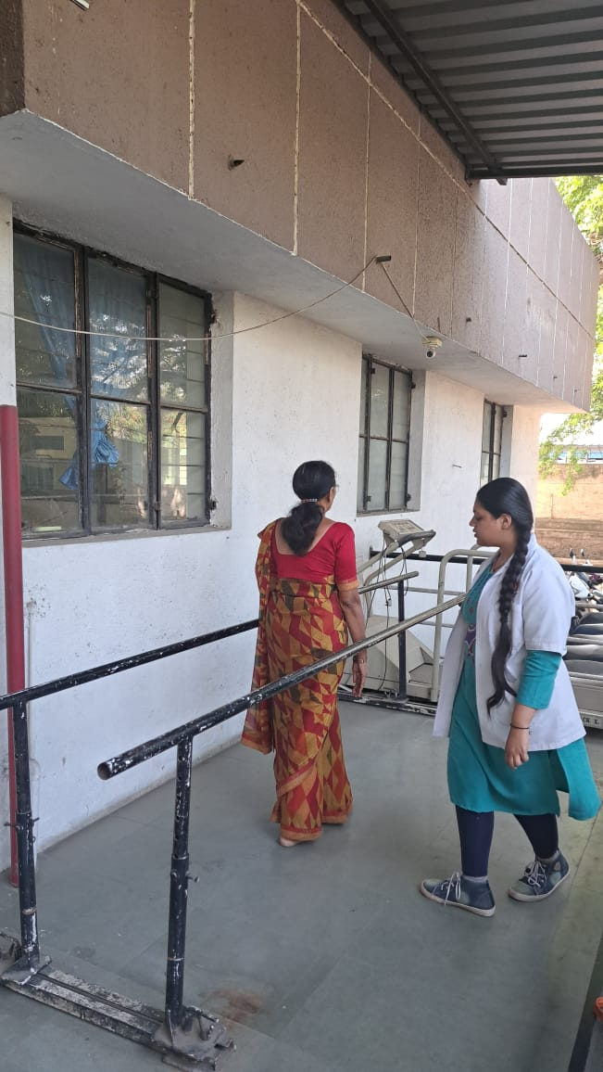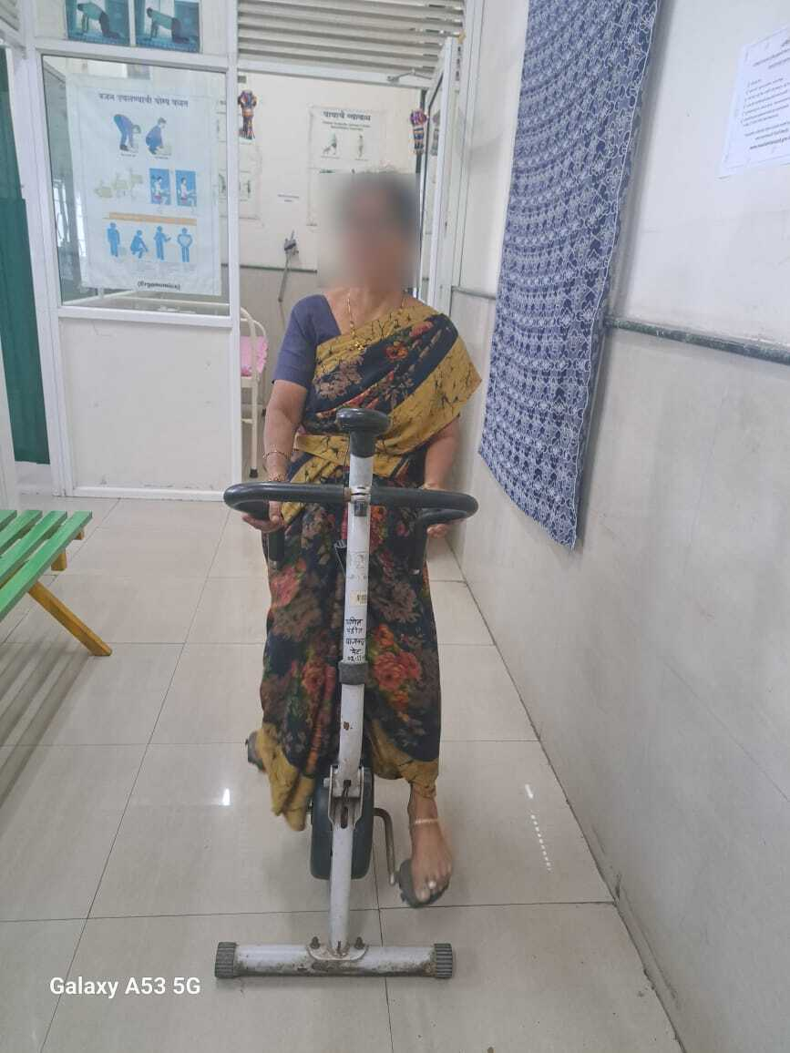 STATIONARY CYCLING RETRO-WALKING

**CONVENTIONAL TREATMENT**

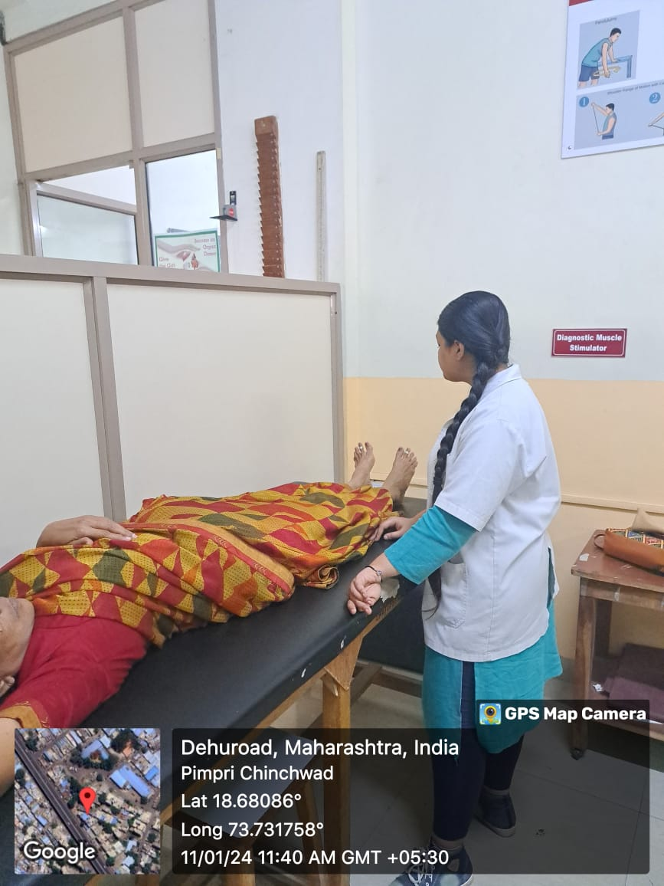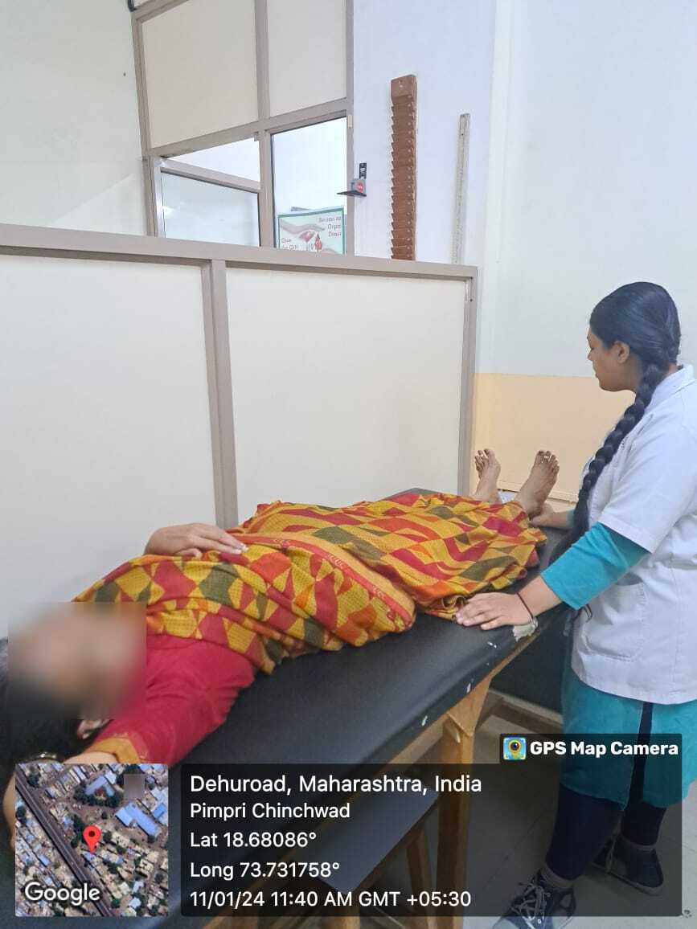

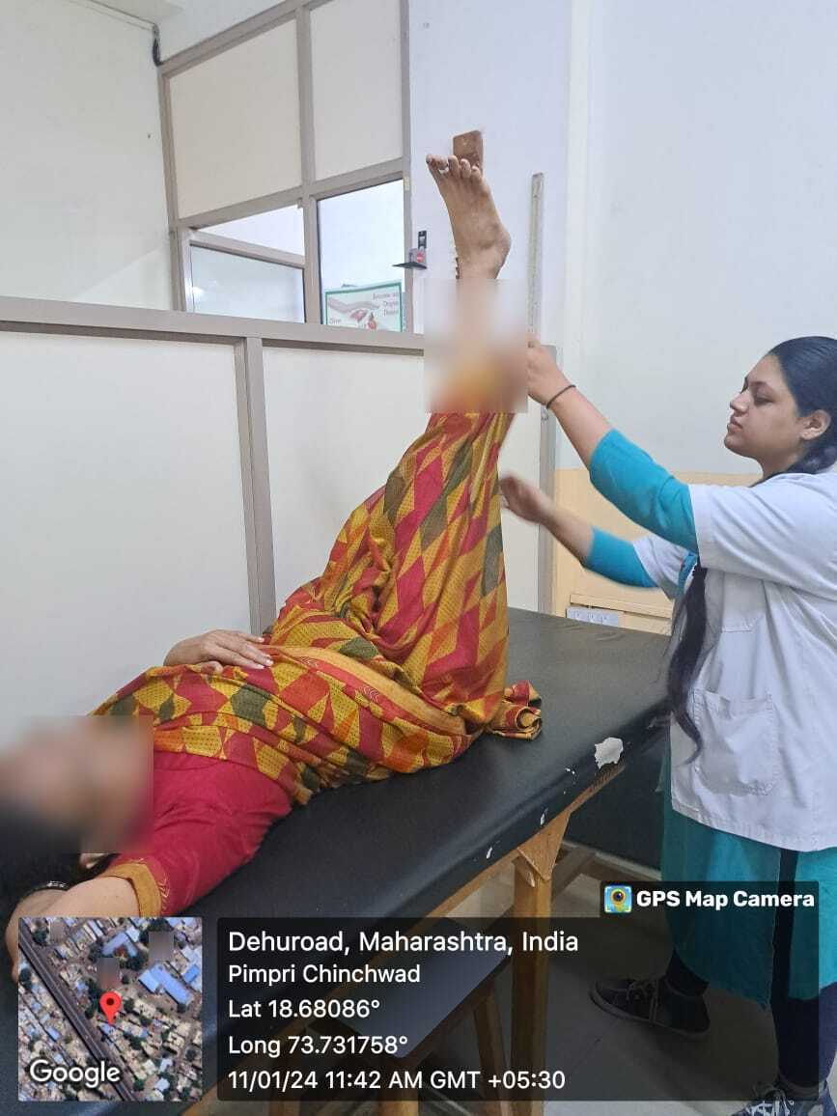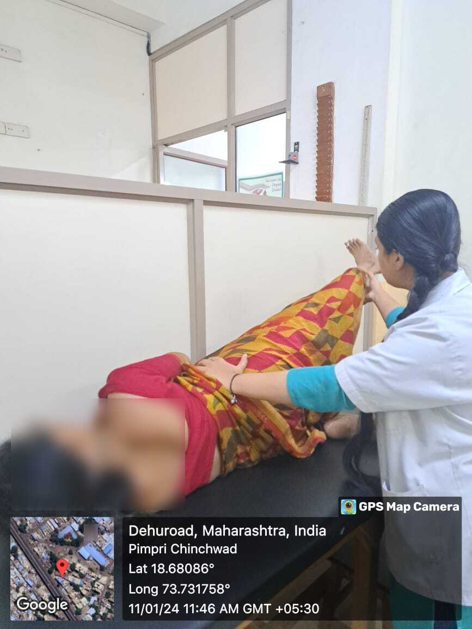

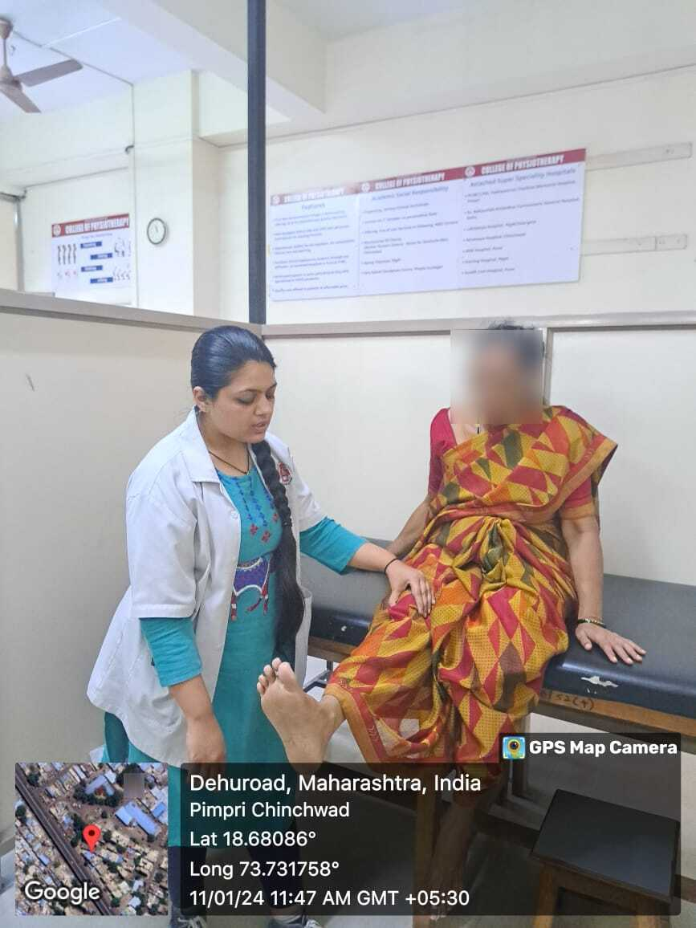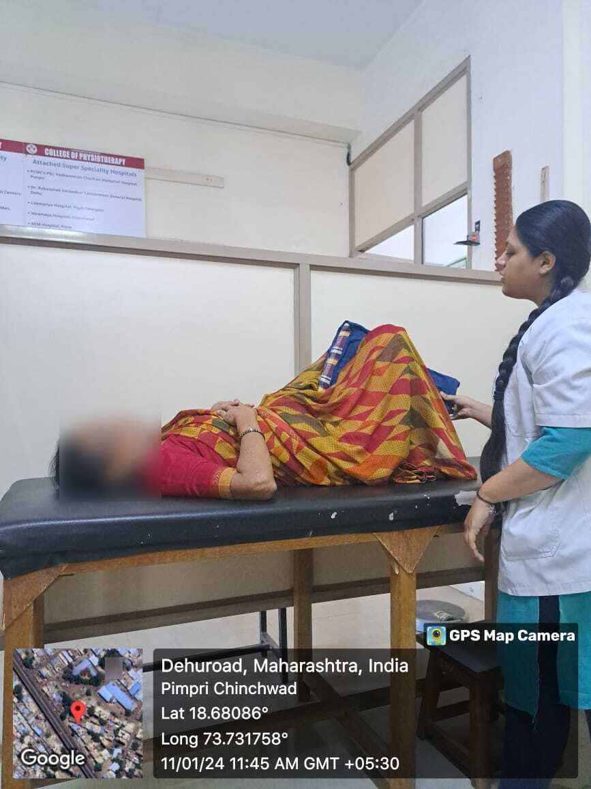

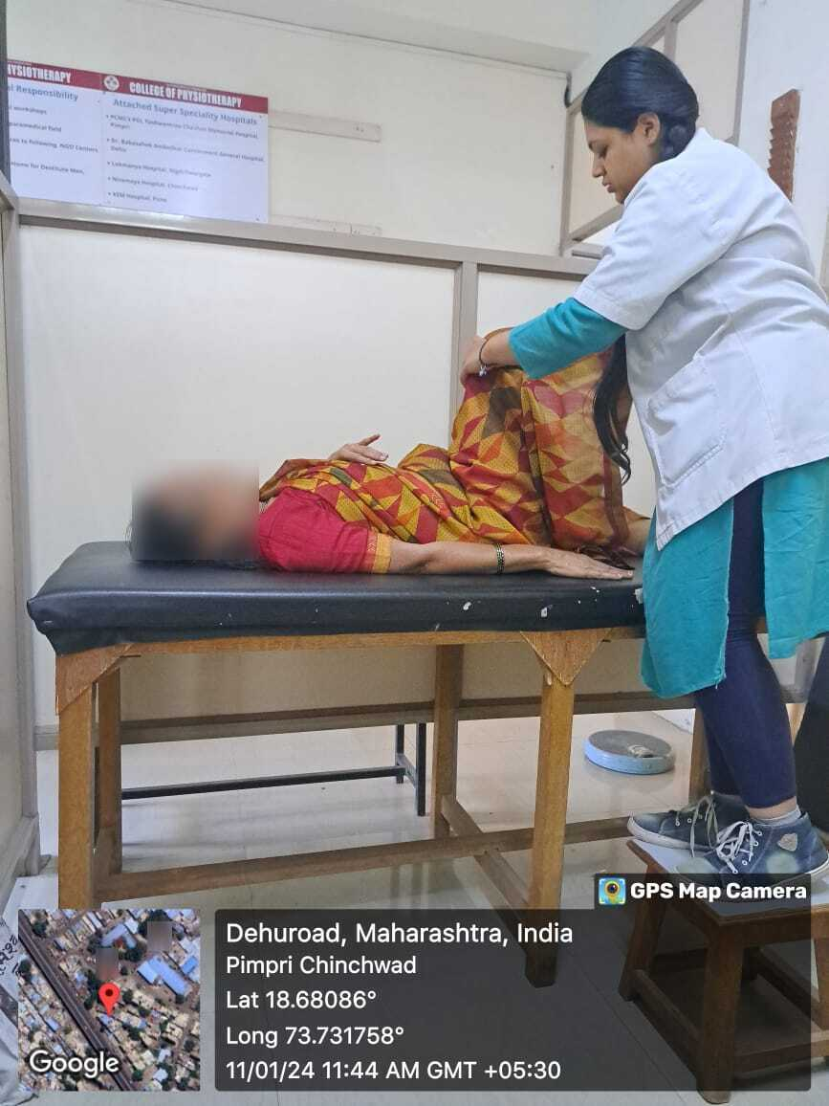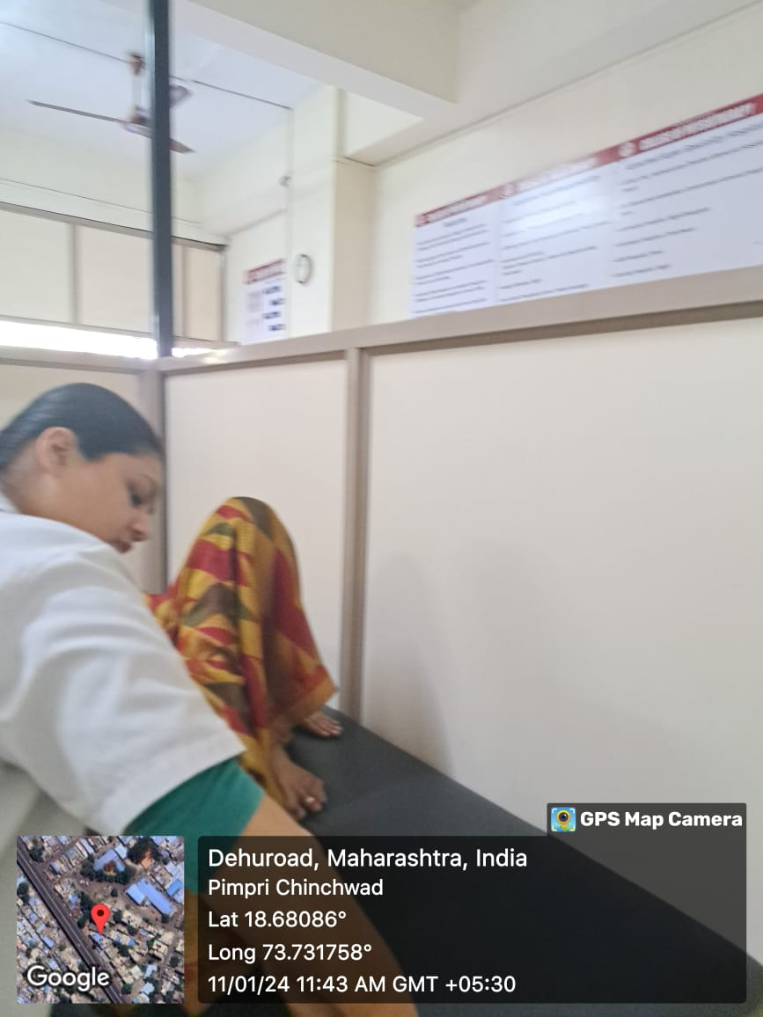

**STATISTICAL ANALYSIS**

A total of 36 subjects were included in the study. The obtained data from the participants of study was entered in MS Excel before it was statistically analysed. Means and standard deviations were calculated for all the needed variables. Statistical analysis was performed with data, and it was analysed by using Instant (version 3.05) software. The statistical analysis was done by using paired and unpaired t-test.

Paired t-test used for statistical analysis to compare pre and post intervention values in groups.

Unpaired t-test used in between group statistical analysis to compare post intervention values of both groups.

**RESULTS**

The present study included 34 subjects with osteoarthritis of knee who met the inclusion criteria. The subjects were equally divided into two groups. Both Group A and Group B consisted of 17 subjects each. Along with conventional therapy Group A received Cycling and Group B received Retro-walking.

As shown in table 1 and graph 1, the mean age for group A is 51.41+3.183 and for group B is 51.529+4.230 respectively. There is no significant difference in mean ages as the p value is 0.9276.

|  |
| --- |
| **TABLE 1:Comparison of age of both groups (Mean age)** |

|  |  |  |  |  |  |  |
| --- | --- | --- | --- | --- | --- | --- |
| **Variables** |  | **Cycling (Group A)** | **Retro-Walking**  **(Group B)** | **t value** | **p value** | **Significance** |
| **Age (Mean+SD)** |  | **51.41+3.183** | **51.529+4.230** | **0.09163** | **0.9276** | **Not significant** |

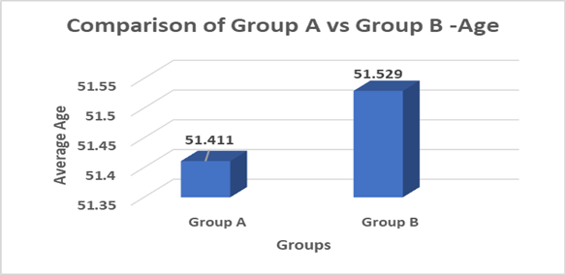

**Graph 1: Comparison of age of both groups**



**Graph 2: Gender Distribution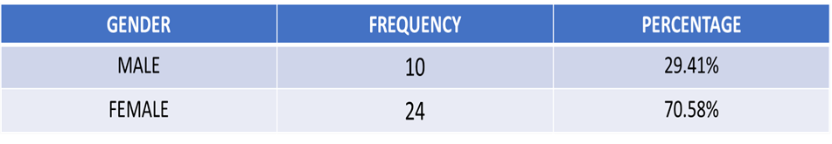comparison of subjects of both groups**

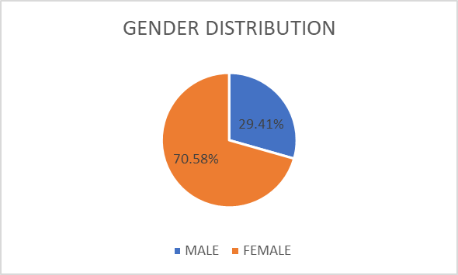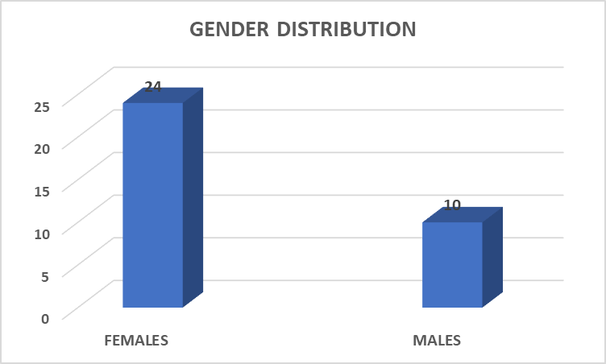

As shown in table 2 and graph 2, the study included,

24 females (70.58%)and 10 males (29.41%).

|  |
| --- |
| **TABLE 3:Distribution according to radiological changes on KL scale** |

|  |  |  |
| --- | --- | --- |
| **GRADES** | **FREQUENCY** | **PERCENTAGE** |
| **GRADE-1** | **15** | **44.11%** |
| **GRADE-2** | **19** | **55.88%** |

**Graph 3: Distribution according to radiological changes based on KL scale**

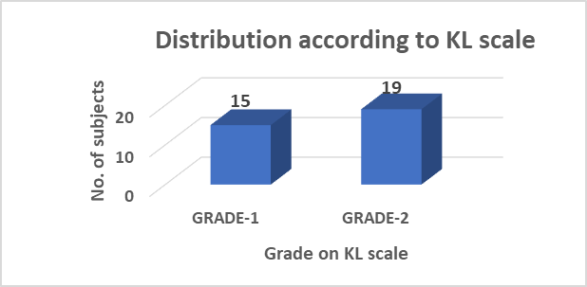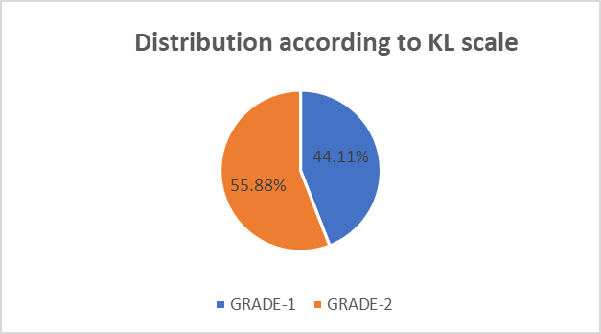

Table 3 and Graph 3 shows the distribution of subjects on the KL scale based on the radiological changes seen on the x-ray.

|  |
| --- |
| **TABLE 4: Intra Group Comparison of VAS (Group A)** |

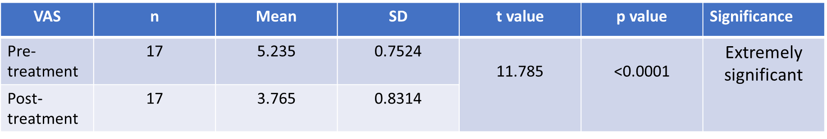

**Graph 4: Intra Group Comparison of VAS (Group A)**

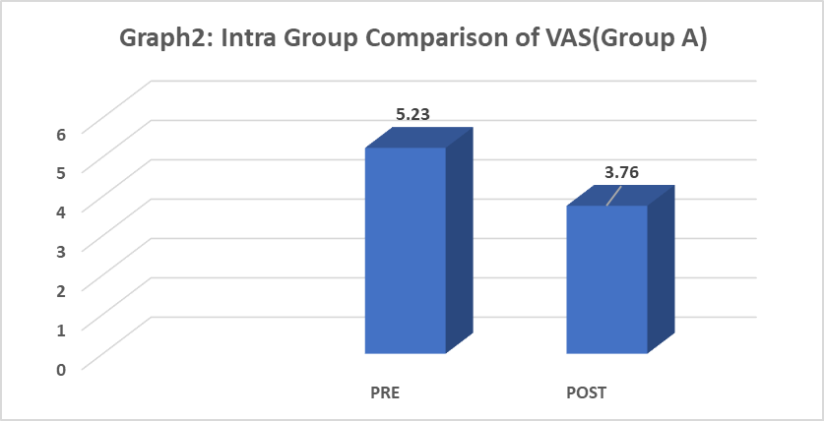

Intra group comparison of pre and post data values of VAS in group A. The pre data of VAS mean is 5.235 with SD 0.75; when it is compared with post mean 3.765 with SD 0.83, the obtained p value is <0.0001 which represent there is extremely significant improvement in pain intensity after intervention (table 4 and graph 4).

|  |
| --- |
| **TABLE 5: Intra Group Comparison of VAS (Group B)** |

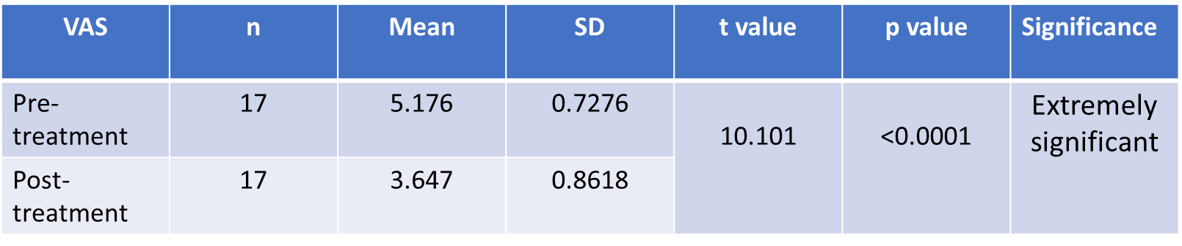

**Graph 5: Intra Group Comparison of VAS (Group B)**

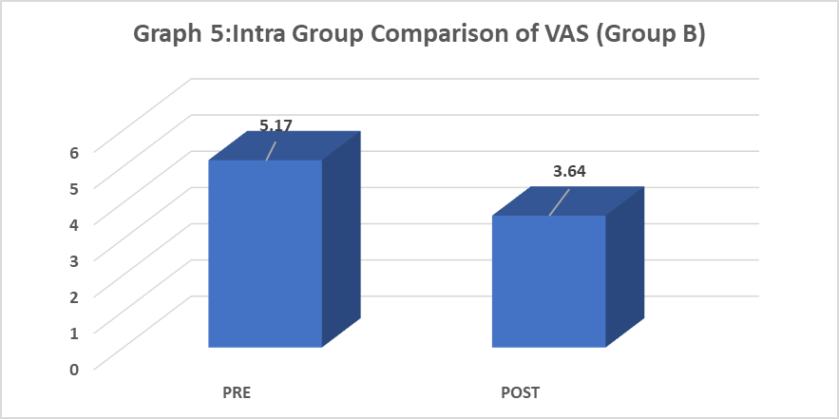

Intra group comparison of pre and post data values of VAS in group B. The pre data of VAS mean is 5.176 with SD 0.72; when it is compared with post mean 3.647 with SD 0.86, the obtained p value is <0.0001 which represent there is extremely significant improvement in pain intensity after intervention (table 5 and graph 5).

|  |
| --- |
| **TABLE 6 : Intra Group Comparison of WOMAC (Group A)** |

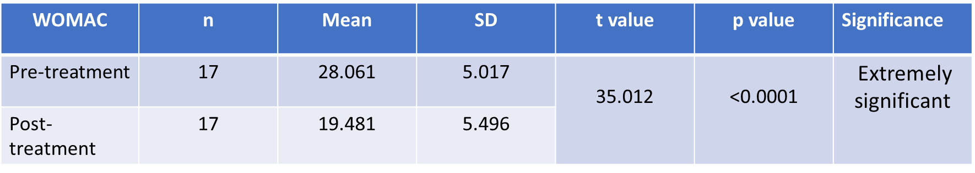

**Graph 6: Intra Group Comparison of WOMAC (Group A)**

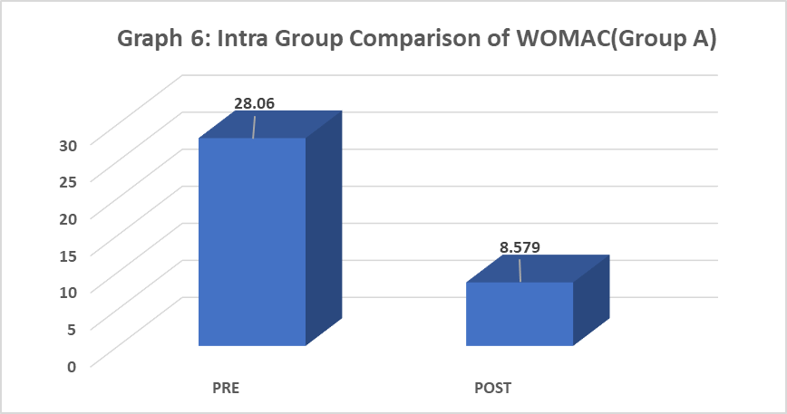

Intra group comparison of pre and post data values of WOMAC in group A. The pre data of WOMAC mean is 28.061 with SD 5.01; when it is compared with post mean 19.481 with SD 5.49, the obtained p value is <0.0001 which revealed statistically significant reduction in pain and functional disability scores post intervention (table 6 and graph 6).

|  |
| --- |
| **TABLE 7: Intra Group Comparison of WOMAC (Group B)** |

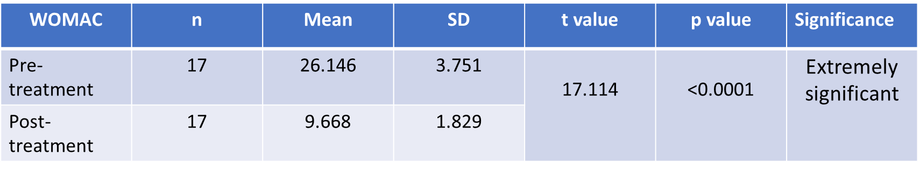

**Graph 7: Intra Group Comparison of WOMAC (Group B)**

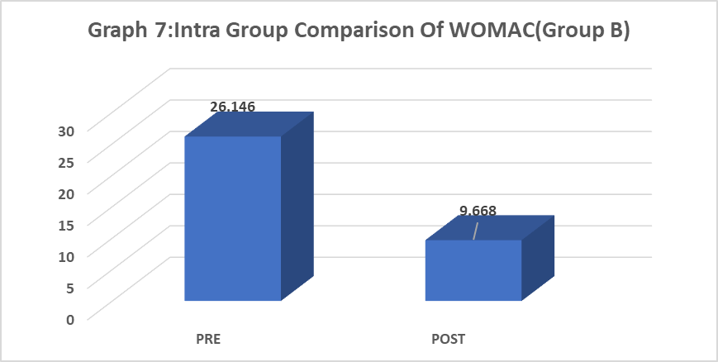

Table 6 and 7 and graph 6 and 7, shows the intra group comparison of WOMAC scores. Which revealed statistically significant reduction in pain and functional disability scores post intervention for both the groups. This was done using paired t -test with group A having (p<0.0001) and group B(p<0.0001).

|  |
| --- |
| **Table 8:Inter group comparison of mean difference of pre and post intervention of both outcomes** |

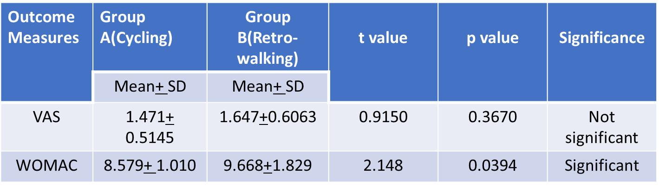

**Graph 8,9: Inter group comparison of both outcomes.**

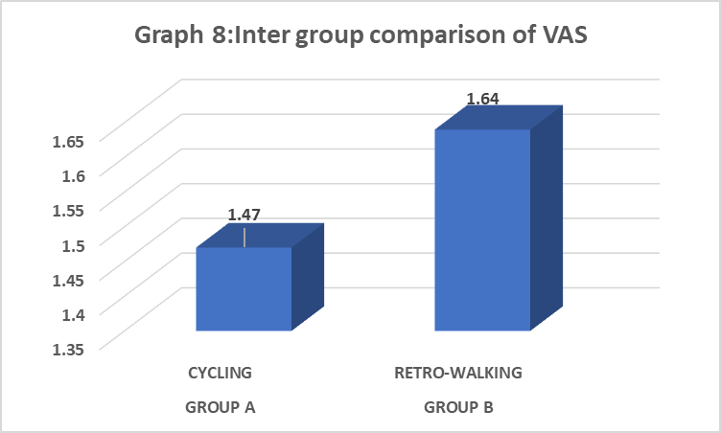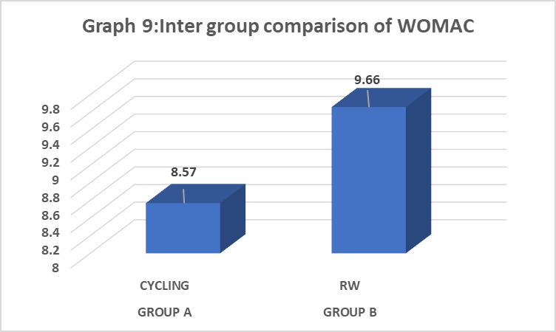

Inter group comparison of mean difference of pre and post intervention of outcomes (table 8). In group A mean difference value of VAS mean is 1.47 with SD 0.51; when it is compared with group B value with mean 1.64 with SD 0.60, the obtained p value is 0.367 which is statistically not significant (Graph 8).

Inter group comparison of mean difference of pre and post intervention of WOMAC (table 8), In group A mean is 8.57 with SD 1.01; when it is compared with group B value with mean 9.66 with SD 1.82, the obtained p value is 0.0394 which is statistically significant (Graph 9).

**DISCUSSION**

The purpose of this study was to compare the effect of cycling versus retro walking on pain and function among patients with osteoarthritis of knee. A total of 34 subjects were included in the study. The subjects were equally divided into two groups. Both Group A and Group B consisted of 17 subjects each. Along with conventional therapy Group A received Cycling and Group B received Retro-walking.

Statistical analysis revealed that there was no significant difference in reduction of pain in both groups i.e., both the groups were equally effective. However, there was significant difference in WOMAC in both the groups. Group B which received Retro-walking is more effective (p= 0.0394) in improving function than Group A which received Cycling (p=0.3670).

A study conducted by Megha S Sheth et al. (2014) to evaluate the effect of cycling versus treadmill walking on function and quality of life in patients with osteoarthritis of knee concluded that cycling and walking both are effective in treating patients with OA knee, and there is no difference in the effect of the cycling and walking . The study also stated that tibio femoral joint forces may be increased during forward cycling, but the same reduce the patellofemoral joint forces. [21]

A study conducted by Farhin Mulla et al.(2017) on the effect of reverse treadmill walking and low intensity cycle ergometry in chronic knee osteoarthritis Cycling is a non-weight bearing activity. It is considered as an alternative exercise modality for patients with knee osteoarthritis. Cycling improves joint mobility, increases muscle strength and flexibility, and improves posture and coordination. Repetitive knee motion is good for arthritic knee because it encourages the production and flushing of fluids through the joint and lubricating it. Low intensity-cycle ergometry is effective inimproving function and gait, decrease pain. Many studies show that tibio femoral joint forces may be increased during forward cycling, but the same reduces patellofemoral joint forces. Which also supports for the additional benefit of reduction of pain and improvement in functional status.

The study also stated that Retro-walking puts less strain on knees and requires less range of motion from knee joints. Also, reverse walking eliminates the typical heel strike to the ground. In forward walking knee joint flexes, extends and then flexes in support phase, prior to flexing and extending during swing. However, the support swing ratio of backward walk is like forward walking with 60% support and 40% swing. Reverse treadmill walking increases stride rate, decreases stride length and increases support time. It reduces the overall range of motion of the knee thereby increasing active functional range. there is improvement in muscle activation pattern, reduction in adductor moment at knee during stance phase of gait and augmented stretch of hamstring muscle groups during the stride; of these may have helped in reducing disability thus leading to improved function. [22]

A study conducted by Ahmad H. Alghadir et al (2019) to evaluate the Effect of 6-week retro or forward walking program on pain, functional disability, quadriceps muscle strength ,and performance in individuals with knee osteoarthritis stated that retro-walking reduces eccentric activity of the quadriceps, while isometric and concentric quadriceps activity was maintained . This is one of the advantages of retro walking over forward walking. Reduced eccentric activity of quadriceps will result in decreasecompressive force at knee joint, therefore, pain intensity at the knee will be reduced.

In Retro-walking walking there is improvement in muscle activation pattern, reduction in adductor moment at knee during stance phase of gait and augmented stretch of hamstring muscle groups during the stride; of these may have helped in reducing disability thus leading to improved function. Reverse walking has an effect on improving strength of hip extensors leading to reduced hip flexion moment during stance phase and thus preventing abnormal loading at knee joint and, in turn the disability and leading to improved function. According to many studies the backward walking allows increases the hamstring activation which generates reduced patellofemoral and lower tibio femoral compression load stress and ACL strain, and therefore backward walking reverses the shear forces in knee joint. Reverse walking is effective in improving extensor muscle activation, gaining flexibility with reduced reaction and shear force directing on joint.

**CONCLUSION**

In conclusion the study provided evidence to support the use of retro-walking and cycling with conventional treatment in reducing pain and improving function in knee joint osteoarthritis. In addition, results supported that retro- walking given with conventional treatment was more effective in improving function than cycling among subjects with osteoarthritis of knee.

# LIMITATIONS

1. The study conducted on small sample size which might effect the generalization of results.

# FUTURE SCOPE

1. The study should be done with a larger sample population.
2. Study can be done for a longer duration to see long term effect of cycling and retro walking on pain, physical function.
3. Patellofemoral, tibio femoral & tri compartmental arthritis differentiation can be done.

# CLINICAL IMPLICATION

1. Physical exercise in the form of walking is cost-effective, accessible, and effective.

2. Aerobic exercises should be incorporated into an exercise program for subjects with osteoarthritis of the knee for reduction of pain and improvement of physical function and quality of life.

**EVALUATION SHEET**

**DEMORGRAPHIC DATA**

NAME –

AGE/GENDER –

OCCUPATION –

ADDRESSS –

DATE OF EVALUATION –

**CHIEF COMPLAINTS –**

**PAIN HISTORY –**

1. SITE –
2. ONSET -
3. NATURE -
4. TYPE -
5. AGGRAVATING FACTORS –
6. RELIEVING FACTORS –

**VAS SCALE [ INTENSITY]**

**PRE VAS**

1. 10

**POST VAS**

0 10

PERSONAL HISTORY –

MEDICAL/ SURGICAL HISTORY –

FAMILY HISTORY –

PHYSIACL EXAMINATION

1. SWELLING -
2. MUSCLE TIGHTNESS -

RANGE OF MOTION – PRE AND POST

|  |  |  |  |  |  |  |
| --- | --- | --- | --- | --- | --- | --- |
| KNEE JOINT | LEFT AROM | LEFT PROM | END FEEL | RIGHT AROM | RIGHT PROM | END  FEEL |
| KNEE FLEXION |  |  |  |  |  |  |
| KNEE EXTENSION |  |  |  |  |  |  |

|  |  |  |  |  |  |  |
| --- | --- | --- | --- | --- | --- | --- |
| KNEE JOINT | LEFT AROM | LEFT  PROM | END FEEL | RIGHT AROM | RIGHT PROM | END FEEL |
| KNEE FLEXION |  |  |  |  |  |  |
| KNEE EXTENSION |  |  |  |  |  |  |

MANUAL MUSCLE TESTING –

|  |  |  |
| --- | --- | --- |
| KNEE JOINT  [PRE] | LEFT GRADE | RIGHT GRADE |
| KNEE FLEXORS |  |  |
| KNEE EXTENSORS |  |  |

|  |  |  |
| --- | --- | --- |
| KNEE JOINT  [POST] | LEFT GRADE | RIGHT GRADE |
| KNEE FLEXORS |  |  |
| KNEE EXTENSORS |  |  |

Q ANGLE – RIGHT - LEFT –

SPECIAL TEST –

OUTCOME MEASURE –

|  |  |  |
| --- | --- | --- |
| WOMAC SCALE SCORES | GROUP A | GROUP B |
| PRE INTERVENTION |  |  |
| POST INTERVENTION |  |  |

**ANNEXURE I**

**CONSENT FORM**

**EFFECT OF CYCLING VERSUS RETRO WALKING ON PAIN AND FUNCTION AMONG PATIENTS WITH OSTEOARTHRITIS OF KNEE.**

I am willing to participate voluntarily as a subject in the dissertation titled, “Effect of cycling versus retro walking on pain and function among patients with Osteoarthritis of knee” conducted by MEGHA YOGESH AGARWAL.

I have been informed to my satisfaction about the nature, purpose, and the duration of the study and thus I agree to fully cooperate and participate in the study. I understand that I do have to bear measure of investigations during the study. The researcher has already assured me that I will be treated well without any untoward effect and the right to confidentially protected.

I am also aware of my right to opt out at any time and prevent my data from being utilized at any phase of the study if I desire. Place: Date: NAME OF THE SUBJECT: SIGNATURE: NAME OF THE RESEARCHER: SIGNATURE:

Place:

Date:

Name of Subject: Signature:

Researcher’s name: Signature:

**संमतीपत्र**

**गुडघ्याच्याऑस्टियोआर्थरायटिसअसलेल्यारुग्णांमध्येवेदनाआणिकार्ययावरसायकलिंगविरुद्धरेट्रोचालण्याचापरिणाम**

मेघाआगरवालयांनीआयोजितकेलेल्या "गुडघ्याच्याऑस्टियोआर्थरायटिसअसलेल्यारुग्णांमध्येवेदनाआणिकार्ययावरसायकलचालवण्याचापरिणामविरुद्धरेट्रो-वॉकिंगचापरिणाम" याप्रबंधातमीस्वेच्छेनेसहभागीहोण्यासतयारआहे.

मलाअभ्यासाचेस्वरूप, उद्देशआणिकालावधीयाबद्दलमाझ्यासमाधानासाठीमाहितीदेण्यातआलीआहेआणिम्हणूनमीपूर्णसहकार्यकरण्यासआणिअभ्यासातभागघेण्याससहमतआहे. मलासमजतेकीमलाअभ्यासादरम्यानतपासाचेमोजमापसहनकरावेलागेल. संशोधकानेमलाआधीचआश्वासनदिलेआहेकीमाझ्याशीकोणत्याहीअप्रियपरिणामाशिवायचांगलेवागलेजाईलआणिगोपनीयपणेसंरक्षितकरण्याचाअधिकारमिळेल.

मलाकोणत्याहीवेळीनिवडरद्दकरण्याच्यामाझ्याअधिकाराचीजाणीवआहेआणिमाझीइच्छाअसल्यासमाझाडेटाअभ्यासाच्याकोणत्याहीटप्प्यावरवापरलाजाऊनये.

**स्थळ:**

**दिनांक:**

विषयाचेनाव: स्वाक्षरी:

संशोधकाचेनाव: स्वाक्षरी:

**ANNEXURE II**

**OUTCOME MEASURE**

**REFRENCES**

1. Kisner C, Colby LA. Therapeutic Exercise: Foundation and Techniques, 5th edi. Philadelphia: F.A. Davis; 2007. p. 314.
2. Cross M, Smith E, Hoy D, Nolte S, Ackerman I, Fransen M, et al. The global burden of hip and knee osteoarthritis: estimates from the global burden of disease 2010 study. Ann Rheu Dis. 2014;73: 1323-30.
3. GBD 2016 Disease and Injury Incidence and Prevalence Collaborators. Global, regional, and national incidence, prevalence, and years lived with disability for 328 diseases and injuries for 195 countries, 1990–2016: a systematic analysis for the Global Burden of Disease Study 2016.

Lancet. 2017;390(10100):1211–59.

1. Iorio R, Healy WL (2003) Uni compartmental arthritis of the knee. J Bone Joint Surg Am 85-A: 1351-1364.
2. Osteoarthritis fact sheet (2005) News from Arthritis foundation, Atlanta, Georgia.
3. van der Esch M, Knoop J, van der Leeden M, Roorda LD, Lems WF, Knol DL, et al. Clinical phenotypes in patients with knee osteoarthritis: a study in the Amsterdam osteoarthritis cohort. Osteoarthr Cartil. 2015;23(4):544–9.
4. Ries MD, Philbin EF, Groff GD. Relationship between severity of gonarthrosis and cardiovascular fitness. Clin Orthop 1995; 313:169-76.
5. Minor MA,Hewett JE,Webel RR, Anderson SK, Kay DR, Efficacy of physical conditioning exercise in patients with rheumatoid arthritis and arthritis and osteoarthritis. Arthritis Rheum1989;32: 1396-405.
6. Brosseau L, Pelland L, Wells G, Macleay L, Lamothe C, Michaud G, Lambert J, et al. Efficacy of Aerobic Exercises for Osteoarthritis (part II): A Meta-analysis. Physical Therapy Reviews 2004; 9:125- 45.
7. Ford ES, Moriarty DG, Zack MM, Mokdad A, Chapman DP. Self-reported body mass index and health-related quality of life: findings from the Behavioural Risk Factor Surveillance Survey.

Obese Res 2001; 9:212–31.

1. Heo M, Allison DB, Faith MS, Zhu S, Fontaine KR. Obesity, and quality of life: mediating effects of pain and comorbidities. Obese Res 2003; 11:209-16.
2. Multani NK. The changing role of Physiotherapists in the management of osteoarthritis knee, “Physiotherapy”. The Journal of the Indian Association of Physiotherapist 2005; 1:15-20.
3. Mangione KK, Mc Cully K, Gloviak A, Lefebvre I, Hofmann M, Craik R. The effects of high intensity and low-intensity cycle ergometry in older adults with knee osteoarthritis. J Gerontol A Biol Sci Med Sci 1999;54:M184-90.
4. Ericson MO, Nisell R. Tibio femoral joint forces during ergometer cycling. Am J Sports Med 1986; 14:285-90.
5. Kovar PA, Allegrante JP, MacKenzie CR, Peterson MG, Gutin B, Charlson ME. Supervised fitness walking in patients with osteoarthritis of the knee. A randomized, controlled trial. Ann Intern Med 1992; 116:529-34.
6. Zhang M, Liu A, Jiang L, Pang J, Guo H, Chen B, Zhao Y, Chen D, Zhan H. The biomechanical effects of backward walking on the knee: a new method for releasing the joint loading. Osteoarthrthritis Cartil. 2015;23 : A121–2.
7. Shankar P, Bhandiwad RMA, Pai H (2013) Effectiveness of retro-walking in chronic osteoarthritis of knee. Innovat J Medi Health Sci 3: 19-22.
8. Alabdelwahab SS, John S (2010) Efficacy of retrowalking on strength and balance in patients with hamstring strain. Br J Sports Med 44: i1-i82 Pradeep Shankar, Renukadevi M. Adithibhandiwad, Harish pai. Effectiveness of retro-walking.
9. Pradeep Shankar, Renukadevi M. Adithibhandiwad, Harish pai. Effectiveness of retro walking in chronic osteoarthritis of knee joint.
10. Bischoff HA, Roos EM (2003) Effectiveness and safety of strengthening, aerobic, and coordination exercises for patients with osteoarthritis. Current Opin Rheumatol 15: 141-144.
11. Megha S Sheth, Megha Thakkar, Neeta N Vyas (2014) Effect of cycling versus treadmill walking on function and quality of life in patients with osteoarthritis of knee.
12. Farhin Mulla, Amrutkuvar Pawar, Trupti Warude (2017) Effect of reverse treadmill walking and low intensity cycle ergometry in chronic knee osteoarthritis subjects.

**MASTER CHART**

|  |  |  |  |  |  |  |  |  |  |
| --- | --- | --- | --- | --- | --- | --- | --- | --- | --- |
|  |  |  |  |  |  |  |  |  |  |
| **GROUP [A]** |  |  |  |  | **PRE INTERVENTION** |  |  | **POST INTERVENTION** |  |
| **Sr.no.** | **AGE** | **GENDER** | **KL SCALE GRADE** | **VAS** | **WOMAC** | **WOMAC %** | **VAS** | **WOMAC** | **WOMAC%** |
|  |  |  |  |  |  |  |  |  |  |
| **1** | **52** | **FEMALE** | **G-2** | **6** | **25** | **26.04** | **4** | **17** | **17.7** |
| **2** | **52** | **FEMALE** | **G-1** | **5** | **21** | **21.87** | **3** | **12** | **12.5** |
| **3** | **57** | **MALE** | **G-2** | **6** | **37** | **38.54** | **5** | **29** | **30.2** |
| **4** | **50** | **MALE** | **G-2** | **6** | **35** | **36.46** | **4** | **28** | **29.16** |
| **5** | **55** | **FEMALE** | **G-2** | **6** | **31** | **32.29** | **5** | **25** | **26.04** |
| **6** | **50** | **MALE** | **G-1** | **5** | **25** | **26.04** | **3** | **16** | **16.66** |
| **7** | **50** | **MALE** | **G-1** | **5** | **29** | **30.2** | **4** | **20** | **20.83** |
| **8** | **56** | **FEMALE** | **G-2** | **6** | **28** | **29.16** | **4** | **20** | **20.83** |
| **9** | **51** | **FEMALE** | **G-2** | **4** | **25** | **26.04** | **3** | **16** | **16.66** |
| **10** | **50** | **MALE** | **G-1** | **5** | **20** | **20.83** | **4** | **12** | **12.5** |
| **11** | **55** | **FEMALE** | **G-2** | **6** | **30** | **31.25** | **4** | **20** | **20.83** |
| **12** | **50** | **FEMALE** | **G-2** | **5** | **25** | **26.04** | **4** | **16** | **16.66** |
| **13** | **47** | **FEMALE** | **G-2** | **5** | **26** | **27.08** | **3** | **18** | **18.75** |
| **14** | **46** | **FEMALE** | **G-1** | **4** | **23** | **23.95** | **2** | **15** | **15.62** |
| **15** | **49** | **FEMALE** | **G-1** | **4** | **22** | **22.91** | **3** | **13** | **13.54** |
| **16** | **55** | **FEMALE** | **G-2** | **6** | **32** | **33.33** | **4** | **25** | **26.04** |
| **17** | **49** | **FEMALE** | **G-2** | **5** | **24** | **25** | **4** | **16** | **16.66** |
|  |  |  |  |  |  |  |  |  |  |
|  |  |  |  |  |  |  |  |  |  |
|  |  |  |  |  |  |  |  |  |  |
| **GROUP [B]** |  |  |  |  | **PRE INTERVENTION** |  |  | **POST INTERVENTION** |  |
| **SR.NO.** | **AGE** | **GENDER** | **KL SCALE GRADE** | **VAS** | **WOMAC** | **WOMAC%** | **VAS** | **WOMAC** | **WOMAC%** |
|  |  |  |  |  |  |  |  |  |  |
| **1** | **47** | **FEMALE** | **G-1** | **5** | **24** | **25** | **4** | **13** | **13.54** |
| **2** | **50** | **FEMALE** | **G-1** | **4** | **25** | **26.04** | **3** | **16** | **16.66** |
| **3** | **49** | **FEMALE** | **G-2** | **6** | **31** | **32.29** | **4** | **20** | **20.83** |
| **4** | **49** | **FEMALE** | **G-1** | **5** | **28** | **29.16** | **2** | **16** | **16.66** |
| **5** | **45** | **FEMALE** | **G-2** | **5** | **25** | **26.04** | **3** | **15** | **15.62** |
| **6** | **58** | **MALE** | **G-1** | **5** | **23** | **23.95** | **4** | **13** | **13.54** |
| **7** | **55** | **MALE** | **G-1** | **5** | **22** | **22.91** | **3** | **12** | **12.5** |
| **8** | **52** | **FEMALE** | **G-2** | **6** | **28** | **29.16** | **5** | **17** | **17.7** |
| **9** | **53** | **FEMALE** | **G-2** | **6** | **26** | **27** | **4** | **17** | **17.7** |
| **10** | **54** | **FEMALE** | **G-2** | **6** | **30** | **31.25** | **4** | **22** | **22.91** |
| **11** | **49** | **MALE** | **G-1** | **5** | **23** | **23.95** | **3** | **16** | **16.66** |
| **12** | **60** | **MALE** | **G-2** | **5** | **26** | **27** | **3** | **17** | **17.7** |
| **13** | **57** | **MALE** | **G-2** | **6** | **30** | **31.25** | **5** | **25** | **26.04** |
| **14** | **47** | **FEMALE** | **G-1** | **4** | **20** | **20.83** | **3** | **12** | **12.5** |
| **15** | **48** | **FEMALE** | **G-1** | **5** | **18** | **18.75** | **4** | **10** | **10.41** |
| **16** | **50** | **FEMALE** | **G-1** | **4** | **22** | **22.91** | **3** | **13** | **13.54** |
| **17** | **53** | **FEMALE** | **G-2** | **6** | **26** | **27** | **5** | **15** | **15.62** |